KPCrew v2 Virtual FO (X-Plane 11, FlyWithLua)
Version 2.1.0.1.2, 09.2021
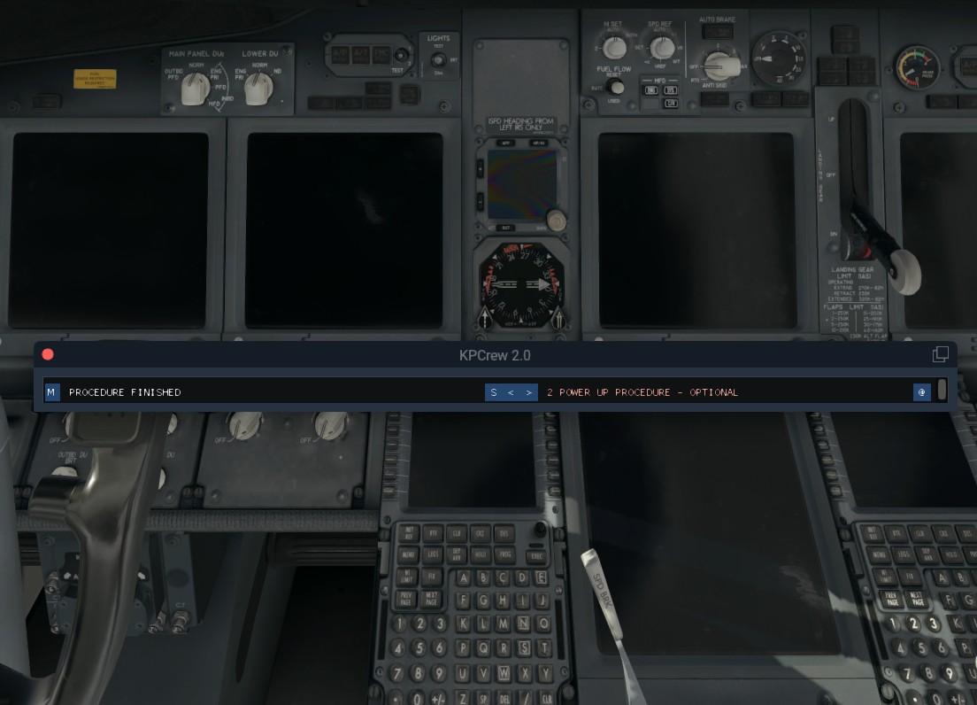
Table of Contents
Introduction 3
Changes 4
Version 2.1.0 4
Installation 5
The KPCrew Zip-file 5
Prerequisites 5
Unpacking and Installing 5
Uninstall 5
How does it Work? 6
Startup 6
The Main Window 6
The Master Button (M) 8
Other Buttons 9
Secondary Button (S) 9
Next/Previous Button (<|>) 9
The Menu Button (@) 9
Flight Information Window 10
Departure Window 11
Approach Window 12
Easy Mode 13
Zibo Boeing 737-800 Features 14
Special Functionalities 14
Other Functions and Commands 15
Generic Commands 15

Introduction
Coming from the FSX/P3D world I know the FS2Crew products which I had for all payware aircraft if available. I always wished that I could get something like that for X-Plane. FlyWithLua turned out to be a great programming environment for X-Plane and I decided to try replicating something like FS2Crew for the Zibo B738. Why the Zibo? Because it is the most accessible and function-rich freeware aircraft in X-Plane and I love the Boeing 737s.
What does it do? Basically you have a helping hand, a virtual first officer which is able to run procedures on your command. These procedures are as close as I can have them to real procedures, partially I get inspiration from FS2Crew (a great tool I would always recommend).
There are other tools out there which do similar things, the most versatile one being XFirstOfficer. I had a KPCrew version with XFirstOfficer but it turned out a lot of work and although quite versatile, restricted me at some locations due to the way the steps are defined. Still XFirstOfficer is great and I can recommend it to people who want to quickly bring together small procedures without programming.
Having said that, KPCrew is one big programming exercise and I can understand that it will be difficult for people without experience in Lua programming to change or extend things. If you want to do that then look at other tools as mentioned above.
Will there be other aircraft? Yes, now it also contains the FJS B737-200 and I plan to have KPCrew support for the IXEG 733 and even the JarDesign A330. Eventually, when I have time for it (the famous words…) I will attempt to cover all my aircraft :-) (Maybe you should not hold your breath here….)
KPCrew went through several iterations, initially I called it Zibocrew. The initial concept was clunky and inflexible. I think I now have a good enough concept to easily extend the scripts. I even have now background events. As it is with Lua, you can see all that I did but when you change code you are on your own – I will not have the time to support this or hold hands with the installation. This is one of the reasons why I hesitate to release this publicly.
I am also working on a way to make the checklists more intelligent. At the moment, using the Easy mode will set all checklist items correctly and tick the box for you. In the future and when using manual mode, the checklist will pause at certain steps until you have corrected the item.

Changes

Version 2.1.0
Easy Mode
Transition altitude and level

Installation

The KPCrew Zip-file
KPCrew comes in a Zip-file and needs to be manually installed under your X-Plane-11 folder.
Modules and Scripts are FlyWithLua specific folders, B738 is the Zibo specific folder. Other aircraft folders will follow in future versions. It also contains this manual.

Prerequisites
You need to have the freeware FlyWithLua NG plugin minimum version 2.7 but I recommend the latest version. See FlyWithLua NG (Next Generation) Edition for X-Plane 11 (Win, Lin, Mac) - Utilities - X-Plane.Org Forum (x-plane.org)
I also use Xchecklist to display and automatize my own clist.txt for each supported aircraft. See Xchecklist (lin+win+mac+32/64) - Utilities - X-Plane.Org Forum (x-plane.org)
And get yourself BetterPushbackC if you really are one of those that have missed out on this great tool :-) Releases · skiselkov/BetterPushbackC · GitHub
Read the instructions for each of those plugins.

Unpacking and Installing
The Modules and Scripting folders need to be placed in <your x-plane root folder>\Resources\plugins\FlyWithLua . If you have older versions of KPCrew files just overwrite them. Please also overwrite your kpcrewconfig.lua file as it may change in the future and KPCrew will not load if it is incomplete.
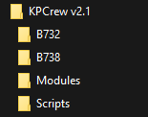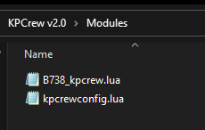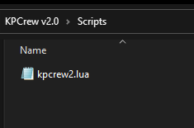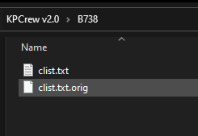
In the aircraft specific folder you will find aircraft specific options. Normally I offer a special clist.txt which works in conjunction with KPCrew.
If you want to use that clist.txt you have to place it in the aircraft folder (e.g. wherever you have your Zibo installed under the <your x-plane root folder>\Aircraft folder. You also need the Xchecklist plugin as mentioned above.

Uninstall
To uninstall remove the lua files from Scripts and Modules and replace the clist.txt with the original.

How does it Work?

Startup
Once you have installed the lua files in the correct places, next time your X-Plane starts will also automatically start KPCrew provided you have loaded a supported aircraft (e.g. the Zibo B738).
You will see the main window which can be pushed around inside the X-Plane window or externalized onto a separate screen (as with many other plugin windows).
If you have Xchecklist installed and used my clist.txt it will also open the 1st page of the checklist. I personally keep the “Auto Hide” option on so that the checklist disappears again when it is finished. KPCrew will call it up when needed.
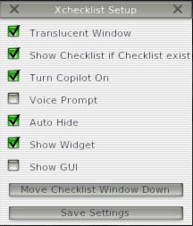

The Main Window
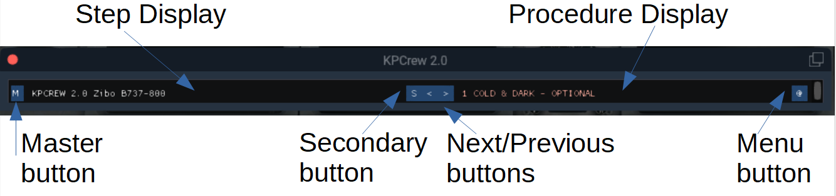
This window will show up whenever you start FlyWithLua and the Lua scripts reload. Should it be closed by you can call it up again by using a FlyWithLua macro or a command that you assign to a button or key:
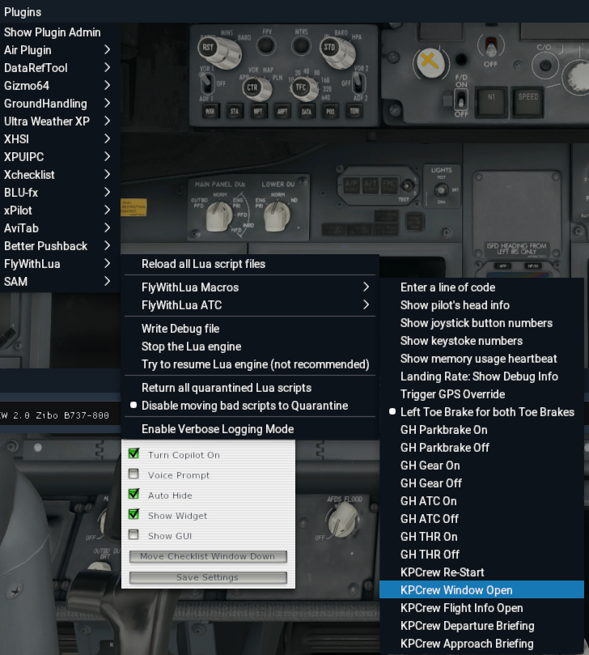
You can also restart KPCrew from scratch by using the KPCrew Re-Start macro. All the macros are also available as commands for programming. To reopen the main window use KPCrew Window Open.
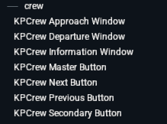
This is what the commands/macros do:
- KPCrew Information Window/Flight Info Open@: Opens the information window.
- KPCrew Master Button/M: Master button, starts procedures and progresses through the steps.
- KPCrew Next Button/>: Selects the next procedure
- KPCrew Previous Button/<: Selects the previous procedure
- KPCrew Secondary Button/S: At the moment only stops a running procedure
- KPCrew Departure Window/Departure Briefing: Opens the form for departure information
- KPCrew Approach Window/Approach Briefing: Opens the form for arrival information

The Master Button (M)
This button is what you will use most. You should program yourself a convenient button or key in X-Plane as you will press the master button for every interactive step and also to start a procedure.
A procedure shown in the let display can be started with the master button like 1 COLD & DARK – OPTIONAL as shown in this sample:
Once started it will run through automatically unless a user interaction is required. In the following screenshot you will be asked to confirm that you have done the CDU Preflight (programmed the FMS/FMC/FMGS). The procedure will wait until you confirm with the Master button.
Then the next steps are performed.
Checklists also run in a special mode. They are a mix of automatic items (that the FO will confirm) and manual items where you have to confirm with the Master button.
Checklists also show as Xchecklist window if you have it installed and use my clist.txt
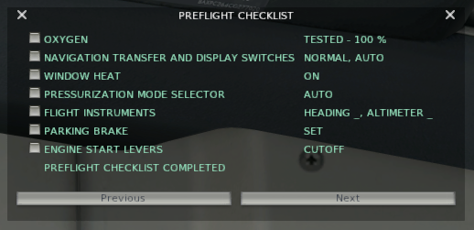
KPCrew will automatically tick the item for you.

Other Buttons

Secondary Button (S)
The secondary button currently only works during a running procedure and will stop the flow. This will be indicated in the left display:

Next/Previous Button (<|>)
With these 2 buttons you can navigate through the procedures while they are NOT running. You can jump over an optional procedure or return to a previous one if something went wrong.

The Menu Button (@)
The menu button will open the flight information and configuration window which is used to setup many parameters for the flight you are planning and also configure the procedures.

Flight Information Window
This window is optional, you do not need it for running the procedures but it will give you information and optimize things like the departure and approach briefings and procedures. This is one of 3 windows, the others are the Departure Briefing and the Approach Briefing window.
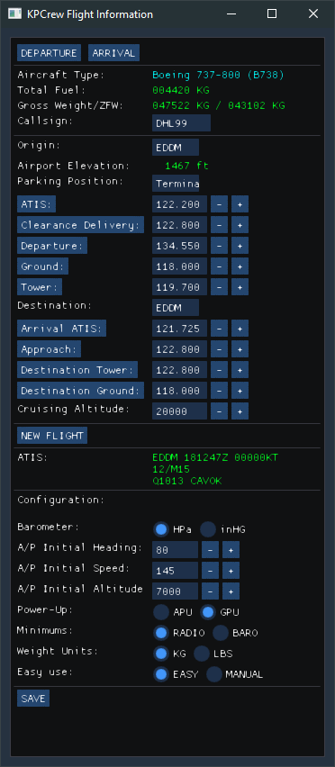
DEPARTURE/ARRIVAL open other windows
Information to the aircraft loaded and the ATC callsign for you to fill in.
Origin airport, Zibo can fill this if FMC done
Parking position fill in.
Various departure frequencies for you to fill in. Pressing on the label will set the frequency in COM1

Destination ICAO and frequencies. Pressing on the label will set the frequency in COM1

Cruising altitude as filed in your flightplan.
Pressing NEW FLIGHT will reset fields.
ATIS string from X-Plane internal weather.

Baro settings in mb or inch
Set what should be set in the MCP/Glareshield initially on startup. Used also for departure.
Power up with APU or GPU when started.
Minimums as radar altitude or baro (DH/MH)
Weight units
Easy mode automates some things, manual makes you do things manually in some areas.
SAVE save all the settings in all 3 windows in kpcrewconfig.lua

Departure Window
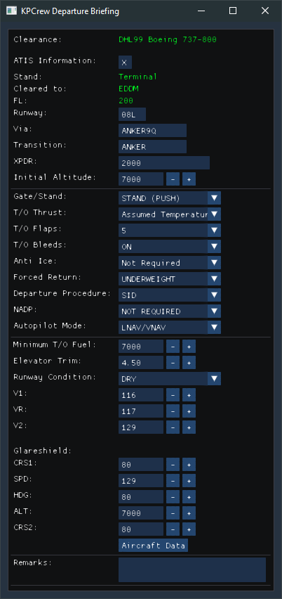
Window with information for the departure and briefing.

Clearance information. Set the ATIS code, runway, SID/Transition if applicable

Transponder code given and initial altitude by ATC
Gate or Stand with push, Stand no push
Rated,De-rated,Assumed,combinations
Takeoff flap setting (will be set for you)
Bleeds/Packs on or off
Anti ice wing, engine or both (no auto)
Under or overweight
SID, Vectors or tracking (see ATC)
Noise abatement departure procedure
Switch lnav/vnav or hdg/flch (aircraft)
Minimum fuel you should have loaded
Elevator trim to set
Dry, wet, contaminated (snow/ice)
V speeds from your aircraft. Can be set if aircraft supports this.

Initial glareshield settings, fields can be filled from aircraft if it is supported

Pressing this button will fill in what is available.

Approach Window
Window with information for the arrival and briefing.
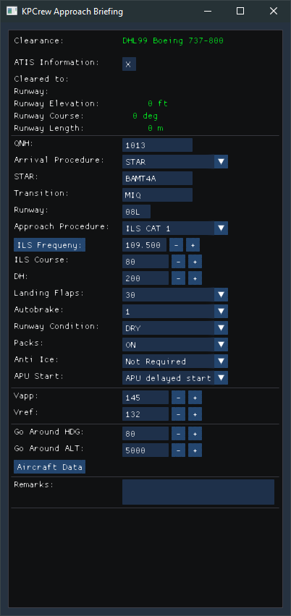
Clearance information
Set ATIS code, Zibo can pull info from FMC is if is is programmed. Will be fields for other aircraft.

Airport QNH setting in Baro unit
STAR, VECTORS
STAR name
STAR transition
Cleared runway
ILS, VISUAL, CAT 2/3, VOR NDB,RNAV, TOUCH & GO CIRCLING
ILS settings, use label to set NAV1
DH/MH depending on settings
Landing flaps, aircraft specific
Autobrake, aircraft specific
DRY, WET, CONTAMINATED
PACKS/BLEED on or off
Wing, Engine or both
After landing start APU or GPU
Approach speeds can come from FMC in some aircraft
Go around heading and altitude to be set
Pressing the button will fill in some values depending on aircraft in use.

Easy Mode
Easy Mode automates the procedures and checklists. When turned on the following support is given:
- Xchecklist opens with every KPCrew checklist and the correct checklist is selected
- For every checklist item the correct setting is made before calling the item
- For every checklist item the answer is spoken and the Xchecklist item ticked off
- During the climb procedure many aspects are automates and callouts are given
Turning Easy Mode off will have you perform many steps yourself and also expects the checklist items to be set appropriately before calling them. You also will have to answer the checklist yourself.

Zibo Boeing 737-800 Features

Special Functionalities
The Zibo has many special datarefs and commands, integrates a setup-menu with Avitab and is generally very accessible for a developer such as me. It is the most feature rich add-on I know.
The Zibo offers many info items for your departure and arrival, this includes fuel planning, airport information and may more. After you have done your CDU Pre-Flight or Arrival setup, I can pull all the information from the aircraft and use it for setting up the cockpit. There will be far less of that for other aircraft, especially default X-Plane 11 based aircraft.
The GPU can be controlled entirely from the procedures. In the future I might also set fuel and cargo based on entries in the KPCrew menus.

Other Functions and Commands

Generic Commands
Use them to program the light and other functions for your Homeycomb yoke or Go-Glight hardware or anything that uses X-Plane commands. Every KPCrew aircraft will have these generic commands set.
kp/xsp/beacon_lights_switch_on
kp/xsp/beacon_lights_switch_off
kp/xsp/dome_lights_switch_on
kp/xsp/dome_lights_switch_off
kp/xsp/nav_lights_switch_on
kp/xsp/nav_lights_switch_off
kp/xsp/strobe_lights_switch_on
kp/xsp/strobe_lights_switch_off
kp/xsp/taxi_lights_switch_on
kp/xsp/taxi_lights_switch_off
kp/xsp/landing_lights_switch_on
kp/xsp/landing_lights_switch_off
kp/xsp/wing_lights_switch_on
kp/xsp/wing_lights_switch_off
kp/xsp/logo_lights_switch_on
kp/xsp/logo_lights_switch_off
kp/xsp/toggle_both_fd
kp/xsp/toggle_both_std

